**Assignment 3**

***Name***: Aditya Matale

***Class:*** AI-B

***Batch:*** B1

***Roll No.:*** 25

**Installing two Virtual Machines on Virtual Box and   
let them communicate with each other.**

To setup communication between two virtual machines (VMs) in we need to ensure that they are connected to the same network and have appropriate network configurations

Follow the following steps:

**1. Launch VirtualBox:** Start VirtualBox and ensure that both VMs are powered on.

**2. Configure Network Adapter Settings:**

- Select the first VM.

- Open Network tap and check the network adaptor with NAT Network are Available or Not.

- If Not Available Follow Step. Click on File menu in VM select the **Preferences** or use Shortcut key. A new Windows are open. Select

**Network -> NAT Networks -> Add NAT Networks**

One network is created. Click On given network and edit NAT network Details**.**

- Repeat these steps for the second VM, ensuring both VMs are connected to the same internal network.

**3. Determine IP Addresses:**

- Use the ifconfig command to determine the IP address of each VM. It is usually under the interface named *eth0* or *enp0s3*.

**4. Ping Each Other:**

- Once both VMs are configured and on the same internal network, we can ping each other using their assigned IP addresses. In the terminal of one VM, use the *ping* command followed by the IP address of the other VM.

ping <other_vm_ip_address>

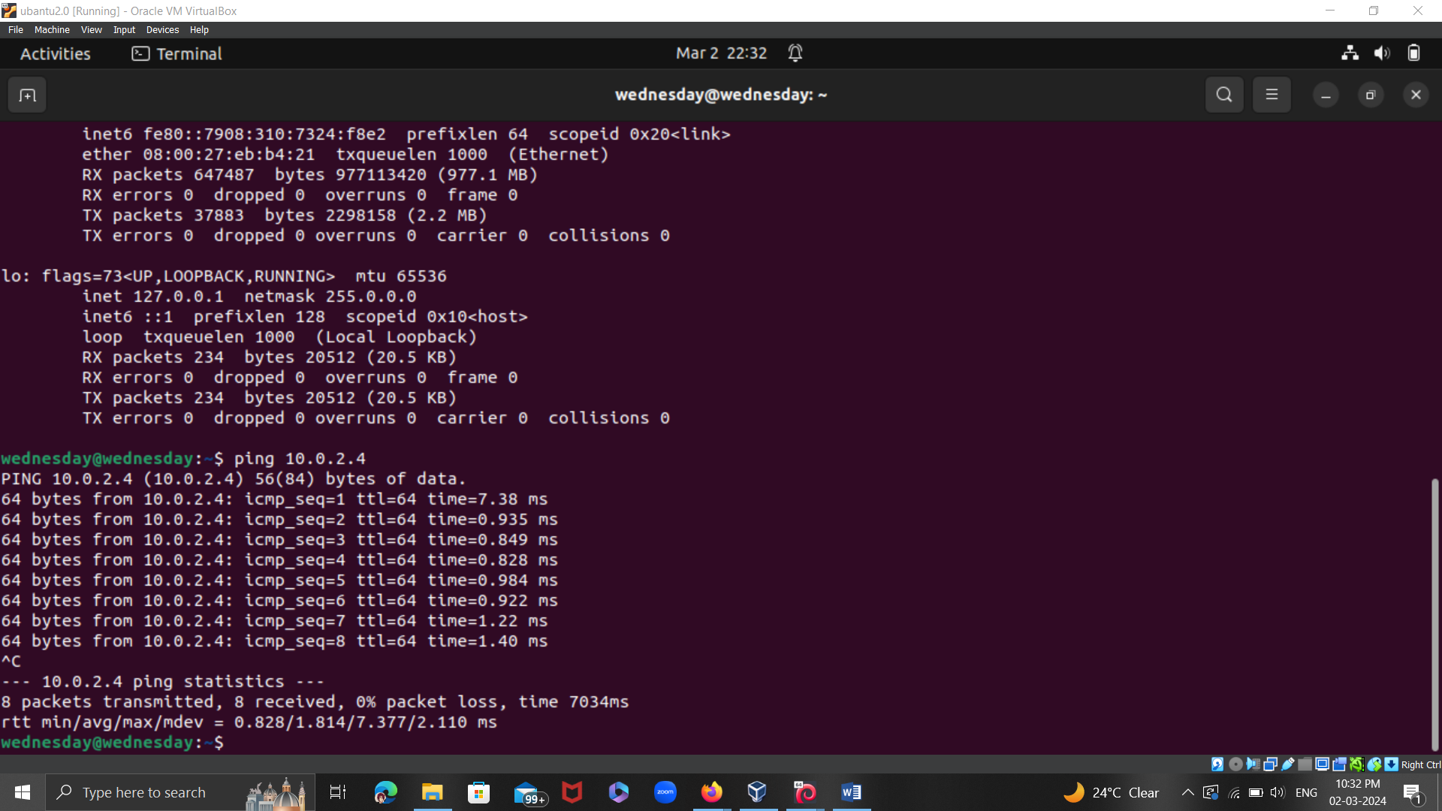

**Ubuntu IP: 10.0.2.4**

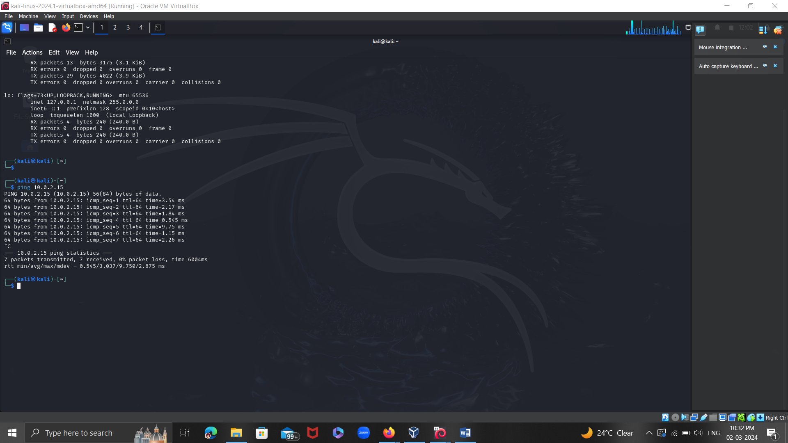

**Kali Linux IP: 10.0.2.15**

**Conclusion:**

Virtual networking is used in Virtual Box to enable communication between virtual machines. Virtual Box creates a virtual network switch when we set up virtual machines to share a network, enabling the VMs to communicate with one another just like they would if they were connected to the same physical network.

Virtual Box allows data packets to be exchanged between virtual machines (VMs) in a manner similar to that of a physical network environment by assigning each VM a virtual network adapter and connecting them to the same virtual network. We can now simulate networked environments and test applications in a safe virtual environment thanks to this, which also permits file sharing, ping, and application interaction.